Contents

Lab Overview 2
Lab Requirements 2
Lab Time Estimate 2
Lab Procedures 2
How To Create Campaign Expressions 2
How To Create a Targeted Discount Campaign 4
Create a New Campaign Customer 4
Create A New Campaign 5
Configure a Discount Campaign Item for a Campaign 7
Targeting Content 8
Creating a Content (Ad) Campaign 9
Summary 9

Lab Overview
This lab provides an introduction to the Commerce Server Campaign System. The Campaign System allows customers to target ads, email and/or discounts to specific user groups. It does so through the use of campaign expressions. Expressions are “English-like” phrases that represent certain groups of users or groups of products. For example, a Commerce Server expression might be “All users over the age of 21 and who live on the west coast”. These expressions are used to determine what ads, discounts and/or email messages users should receive from Commerce Server.

In this lab, you will create a campaign in Commerce Server. The campaign will consist of a few product discounts and an ad or two. Both the ads and the discounts will be targeted to specific users based on their user profile. At the conclusion of this lab, you will be able to implement basic targeting techniques using Commerce Server.

Lab Requirements
This lab assumes that you have added 3 custom attributes to the user profile object. They are age, gender and region. The lab also assume that you have at least one or more catalogs installed on the Commerce Server site, and at least 1 user login account.

Lab Time Estimate
This lab can be completed in approximately 60 minutes.

Lab Procedures
The first step in implementing a campaign is to create campaign expressions. Expressions are “English-like” phrases that define certain user groups or product groups. Once these expressions are defined, they can be used to personalize both content and discounts. We will implement the following expressions in this step:

- Seniors
- Low Price Shoppers
- Medium Price Shoppers
- Luxury Shoppers
- East Coast Shoppers
- West Coast Shoppers

How To Create Campaign Expressions
Here are the steps needed to create an expression:

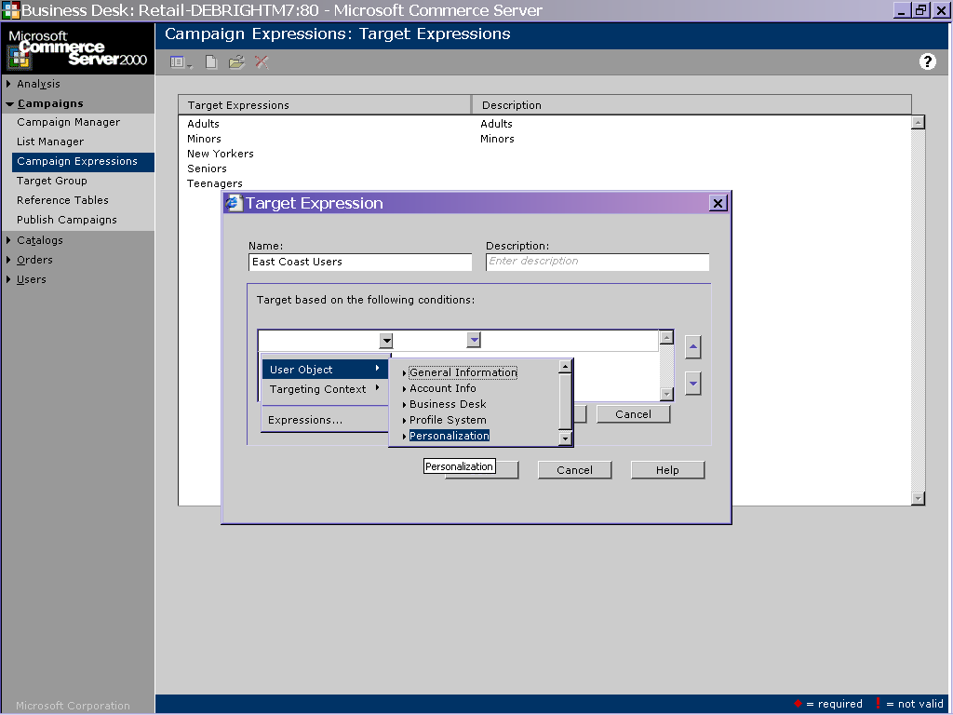

- Open the BizDesk for your CS application.
- Select Campaigns → Campaign Expressions.
- Click the icon and select the “Target Expressions” menu option.
- Next click the icon. This will pull up the Target Expression dialog page, which you will use to create your new expression.
- In a previous lab you should have added several custom attributes to the UserObject profile. If you have not completed the User Profile lab, please do so before continuing.
- In the Target Expressions dialog, name this new expression “Seniors”.
- In the “Description” field type “Customers over the age of 59.”
- To begin defining the criteria for this new expression, click the “New” button. You will notice that you can now begin selecting criteria from several combo-boxes
- Click the first combo-box, then select UserObject → General Info → Age. This tells Commerce Server that you want to use the user’s Age as part of this expressions definition.
- Click the next combo box. This box allows you to tell Commerce Server when the expression is met. Select “Is greater than”.
- The final box is a textbox that allows you to provide a value for Commerce Server to check against. Enter 59.
- At this point, your expression should read “Age…is greater than…59”. Click the “Save” button to save your expression.
- Repeat steps 4-12 to create the following expressions:

Name | Criteria
Low Price Shoppers | PriceRange…is less than ...15000
Medium Price Shoppers | PriceRange…is greater than 15000…AND…PriceRange…is less than 30000
Luxury Shoppers | PriceRange…is greater than…30000
East Coast Shoppers | Region…is equal to…East
West Coast Shoppers | Region…is equal to…West

How To Create a Targeted Discount Campaign
Commerce Server supports 3 basic types of campaigns. They are ad, email and discount campaigns. Ad and discount campaigns are run in real-time while the user is visiting the site. Email campaigns are typically run offline. In this lab, we will implement a new a new discount campaign. The steps are provided below.

Before we create the campaign, please note that the campaign system follows a hierarchy:

→ Customer
→ Campaign
→ Campaign Items

A “Customer” can have one or more “Campaigns”, and a “Campaign” can have one or more “Campaign Items”. For example, let’s say you have a site that sells products from the Acme Widget Company. You could setup Acme as a “Customer”. Acme might want to run several campaigns (“Christmas Campaign”, “Brand Awareness Campaign”, etc). Each campaign can have various ads and/or discounts (campaign items) associated with them. Let’s implement a campaign to see this in action.

Create a New Campaign Customer
The first step in setting up a campaign is to identify the customer for which the campaign in being created. Here are the steps needed to implement a new customer:

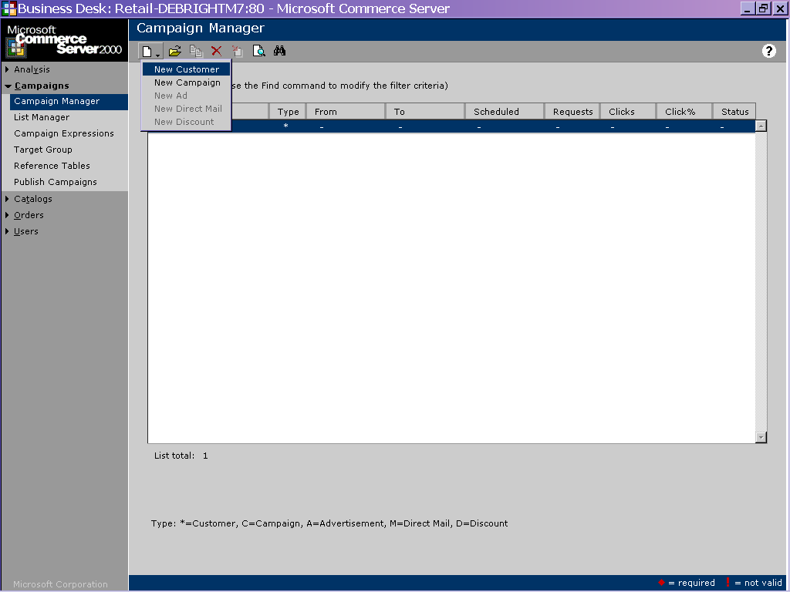

- Open BizDesk.
- Select Campaigns → Campaign Manager.
- Select the icon and select “New Customer”.
- Name the Customer “Toyota”. You may also provide other values if you’d like, but they are not required to complete this lab.
- Click the icon to save the customer information and exit the page.

Create A New Campaign
Once you have successfully added a campaign customer, you can add one or more campaigns for the customer. To add a campaign, do the following:

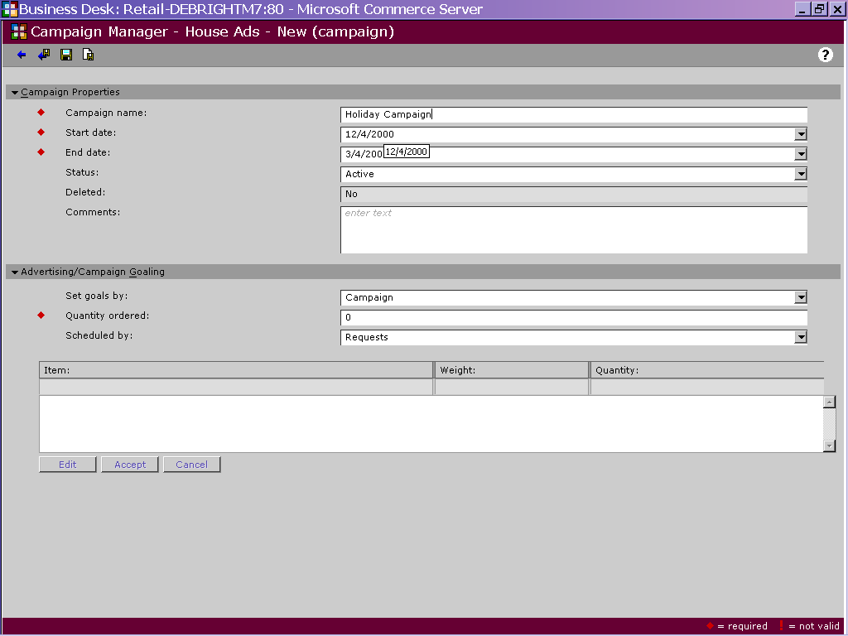

- Open BizDesk
- Select Campaigns → Campaign Manager.
- Click the name of the customer for which you want to create a new campaign. In this case, the customer is Toyota. Toyota should be highlighted.
- Select the icon and select “New Campaign”.
- Fill in the page with the following options:

Name | Value
Campaign Name | East Coast Camry Incentives
Start Date | 11/24/2000
End Date | 2/28/2001
Status | Active
Set Goals by | Campaign
Quantity Ordered | 10000
Scheduled By | Requests

- Click the icon to save the campaign information and exit the page.

Configure a Discount Campaign Item for a Campaign
Once you have successfully named your campaign, you can now add campaign items to the campaign. First, we will implement a discount campaign. A discount campaign gives specific users a percentage or dollar amount off of the product’s list price. Commerce Server allows you to decide which users qualify for a discount based on campaign expressions or target groups.

In this example, imagine that the Toyota sales department finds that sales of their Camry model has been particularly slow in the East region. To stimulate sales, they are offering a 10% discount to East Coast shoppers. Here are the steps needed to implement such a discount campaign:

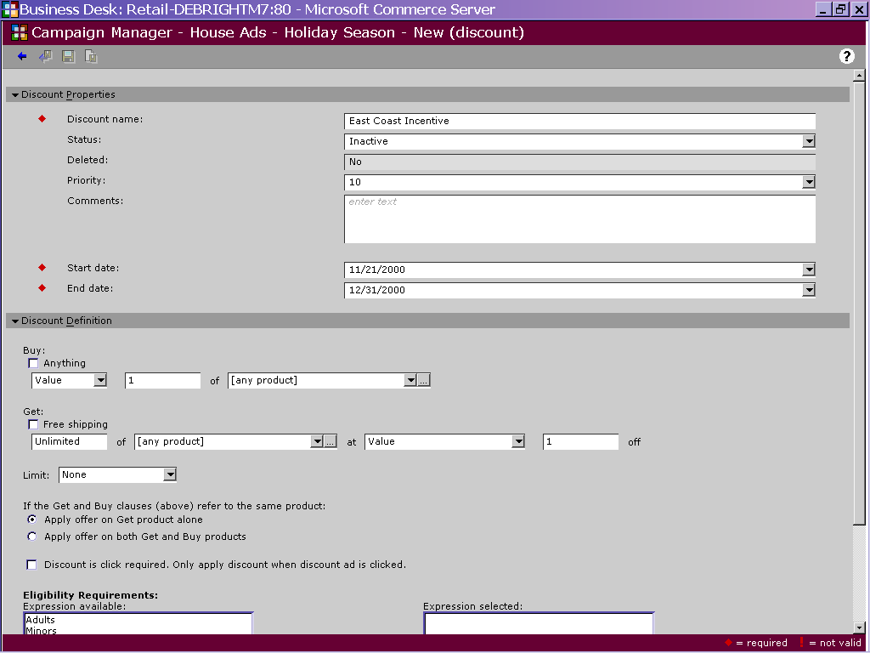

- Open BizDesk
- Select Campaigns → Campaign Manager.
- Click the arrow to the left of name of the customer for which you want to create a new campaign. In this case, the customer is Acme Inc. Acme Inc. This should show you the name of the campaign we created in the previous step.
- Click the “East Coast Toyota Campaign” so that it is highlighted.
- Select the icon and select “New Discount”.
- Fill in the page with the following options:

Discount Properties
Name | Value
Discount Name | East Coast Camry Discount
Status | Active
Priority | 10
Status | Active
Start Date | 11/24/2000
Quantity Ordered | 2/28/2001

Discount Definition
Name | Value
Buy…1…of…[use Product Picker to select Toyota Camry category] | Checked
Get…at | Percent (%)
Get…off | 10
Limit | None
Eligibility Requirements | East Coast Shoppers

- Click the icon to save the campaign information and exit the page.

At this point, you have told Commerce Server to give a 10% discount to all shoppers who live on the East Coast. At this point you should test your application to ensure the discount is in effect. Here’s how you test:

- First, you will need to publish your discounts to the web site. You do this by selecting the “Publish Campaigns” option in the BizDesk Campaigns module. Highlight the “discounts” cache, and then click the icon.
- Next, we want to ensure that only East Coast shoppers get the discount. To do this, log in as “eastuser”. This user account was setup in a previous lab exercise. Add a Toyota Camry to your basket. You should get a 10% discount.
- Now, log in as “senioruser”. This user does live in the “east region”, and therefore should not get the discount.

Targeting Content
In addition to targeting discounts, Commerce Server can also personalize content for site users. The content personalization engine is fairly robust, and allows personalization of content based on campaign expressions, target groups, date/time and page groups. The personalization engine also has advanced capabilities to provide for a smooth delivery of content over the life of a campaign. For example, if content is supposed to be displayed 10,000 times from 06/01 through 09/01, the personalization engine will can be configured to spread out the delivery of this content so that it spans the entire 3-month delivery target.

Creating a Target Group
In this example, we will personalize the site based on the user’s “price sensitivity”. For users who indicated they are interested in “luxury” cars, we will target content that are for Mercedes and BMW vehicles. However, for medium and low price shoppers, we will target Ford, Honda and other vehicles that fall within this price category.

The first step in implementing this example is to define “target groups”. Target groups allow Commerce Server users to group multiple campaign expressions into a single personalization rule. For example, you could combine the “West Coast Shoppers” expression and the “Senior Citizens” expression into a single target group named “West Coast Senior Citizens”.

Target groups support several types of targeting. These include “target”, “exclude”, “sponsor” and “require”. These options give you fairly detailed control over which users should set certain content. For example, we could create a group called “Only West Coast Shoppers” that would “require” west coast shoppers to receive content and would “exclude” all others. Our example below helps to further clarify target groups and there use within your site:

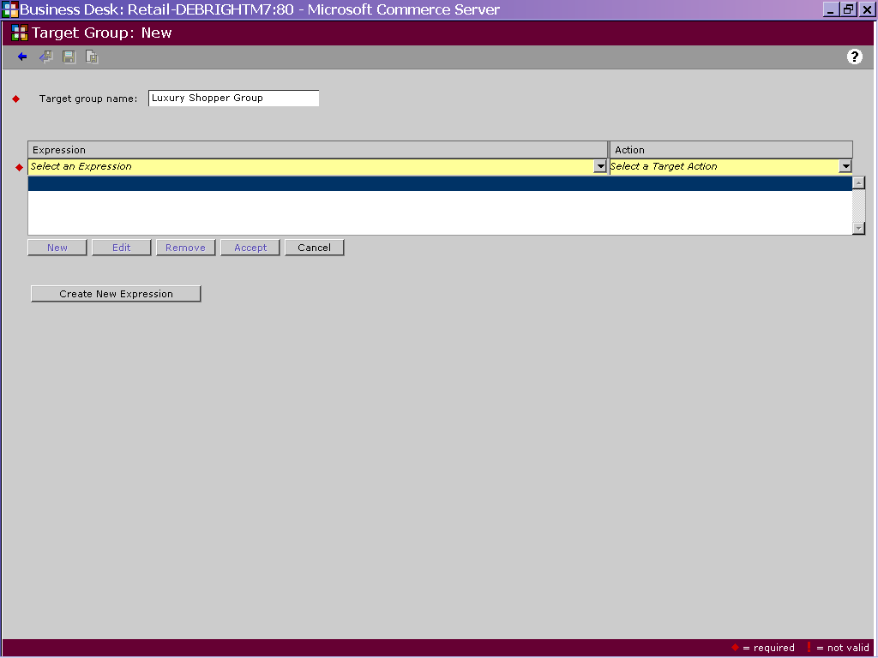

- Open BizDesk
- Select Campaigns → Target Group.
- Select the icon to create a new target group.
- Use the two tables below to configure the target groups:

Luxury Shopper Group
Require | Luxury Shoppers
Exclude | Medium Price Shoppers
Exclude | Low Price Shoppers

Non-Luxury Shopper Group
Require | Medium Price Shoppers
Require | Low Price Shoppers
Exclude | Luxury Shopper

By using the “require” and “exclude” options, we have created very specific business rules to define our content targets. The content selection engine can now display the appropriate content to our luxury and non-luxury shoppers based on these settings.

Creating a Targeted Content (Ad) Campaign
Content can be targeted to users based on either individual campaign expressions or by target groups. In this case, we will use our 2 target groups to deliver our content to users. We will configure “Mercedes Benz” content to be delivered to our “Luxury Shopper Group”. We will then configure “Ford” content to be delivered to our “Non-Luxury Shopper” group:

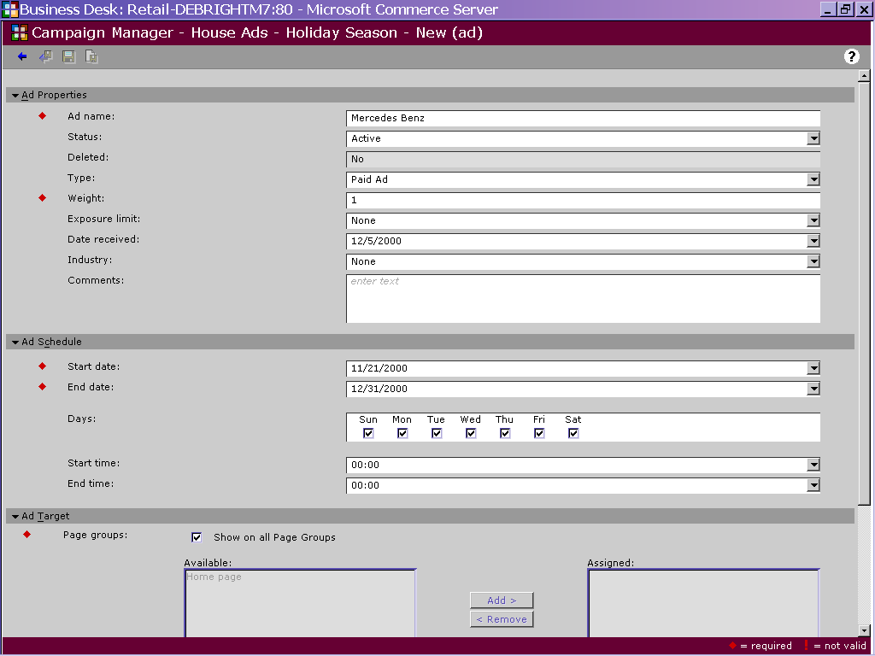

- Open BizDesk
- Select Campaigns → Campaign Manager.
- Click the arrow to the left of name of the customer for which you want to create a new campaign. In this case, the customer is Acme Inc. Acme Inc. This should show you the name of the campaign we created in the previous step.
- Click the “East Coast Toyota Campaign” so that it is highlighted.
- Select the icon and select “New Ad”.
- Use the following table to configure the Mercedes content. NOTE: If a particular setting is not in the table, simply take the default value:

Ad Name | Mercedes Benz
Status | Active
Type | Paid Ad
Weight | 1
Exposure Limit | None
Date Received | (Current Date)
Industry | Automotive
Start Date | (Current Date)
End Date | (1 month from the current date)
Days | (All checked)
Start time | 00:00
End Time | 00:00
Target Groups | Luxury Shopper Group
Size | Basic Car (270 x 135)  NOTE: This content size is not standard. Use the “Reference Tables” option in the Campaigns BizDesk to add this custom content size.
Type | Image
Image URL | http://localhost/retail/images/benz2.jpg
Click URL | http://localhost/retail/images/benz2.jpg
Alternate Text | Only for our Luxury users. Now, give us your money!!!

- Click the icon to save the campaign information and exit the page.
- Repeats steps 1-7 to configure the “Ford” content:

Ad Name | Ford Motors
Status | Active
Type | Paid Ad
Weight | 1
Exposure Limit | None
Date Received | (Current Date)
Industry | Automotive
Start Date | (Current Date)
End Date | (1 month from the current date)
Days | (All checked)
Start time | 00:00
End Time | 00:00
Target Groups | Non-Luxury Group
Size | Basic Car (270 x 135)
Type | Image
Image URL | http://localhost/retail/images/ford1.gif
Click URL | http://localhost/retail/images/ford1.gif
Alternate Text | Built Ford tough! Too bad you cant afford a Benz though!

Last we need to test our personalized content. Log into the site as “luxuryuser”. You should notice that you receive Mercedes Benz content. Now, login as “eastuser”. You should receive Ford content.

The content selection framework is fairly easily to configure, yet very powerful. Although not covered in the lab, the content selection framework is also extensible. Take a moment and look at the content selection pipeline files for your site. They can be found in the site’s virtual directory in a folder named “pipelines”.

Summary
In this lab, you learned how to implement a Commerce Server campaign. Campaigns allow you to provide targeted ads, email and discounts to specific groups or types of users. Commerce Server provides this targeting through the use of expressions.

Commerce Server also allows customers to measure the effective of their campaigns through the use of the Commerce Server Business Analytics Tool. Please see the Commerce Server 2000 documentation file for more information on reporting against Commerce Server 2000 campaigns.

