Catalog Management Lab

Catalog Management Lab 1
Objective 2
Setup 2
Lab: How to Use the Business Desk to Create a CS2000 Catalog 2
Create Product Properties 2
Create A New Product Definition 3
Create A New Category Definition 4
Create A New Catalog Instance 4
Add Category Values to Category Definition 5
Category Hierarchy 5
Add Products to Catalog 6
Custom Pricing 7
Applied Learning 8
Extra Credit Exercise 8

Objective
The objective of this lab is to use the Microsoft Commerce Server 2000 Business Desk to implement a site catalog. This lab will cover many of the basic features of the CS2000 Catalog system, including:

Topics Covered
- How to create property, product and category definitions.
- How to add new products, product variants and product categories.
- How to categorize products.
- How to associate similar products into product families.
- How to search the site catalog.
- How to apply both category pricing and custom pricing to products.

These topics will provide the basic knowledge needed to get started with the CS2000 Catalog Management System. For a more exhaustive overview of Catalog System please reference the Commerce Server 2000 online Documentation.

(The estimated time to complete this lab is 75 minutes.)

Setup
In order to complete this lab, you will need a machine setup with Windows 2000, SQL Server 2000, IE5.5 and Commerce Server 2000 RC0.

Lab: How to Use the Business Desk to Create a CS2000 Catalog
The first step in building a catalog is to define your product “properties”. Product properties are used to define products. For example, in this lab you will define a new product named “Car”. This product will have several properties, including name, description, year, make, model, etc. Before this “Car” product can be defined, you must first create all of its properties.

The following section walks through creating product properties for the “Car” product.

Create Product Properties
Car Properties
Property Name | Property Type
CarYear | Number (min = 1990, max = 2010)
CarMake | Multiple Choice (Mercedes, BMW, Toyota, Lexus, Ford, Chevrolet)
CarModel | Text (minLength = 0, maxLegth = 20)
CarNewUsed | Multiple Choice (New, Used)
CarMileage | Number (min = 0, max = 300000)
CarVIN (vehicle identification number) | Text (minLength = 0, maxLegth = 32)

To create these product properties, do the following:

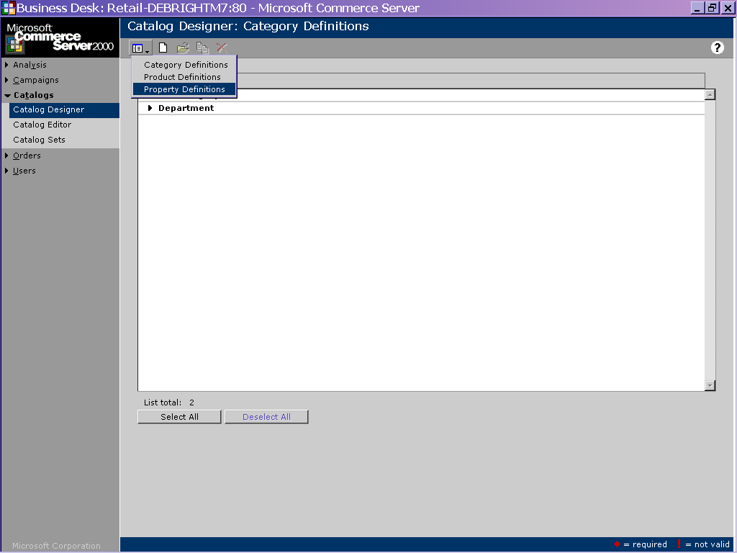
Figure 1 - Catalog Designer

- Start the Business Desk.
- Click “Catalogs”.
- Click “Catalog Designer”. The Catalog Designer is the tool used to define the catalog schema.
- Click the icon.
- This will present a menu of three definition options.
- Click “Property Definition”. This option allows you to create new properties for the product
- Click the icon to add a new property.
- Create properties for each property listed in the table above. Be sure to assign the appropriate data type listed in the table. For multiple choice properties, use the first choice as the default choice. You can use the icon to save each property and add another.
- Give the property a display name of your choosing. Feel free to experiment with the other property settings, but do not select the “Assign to all product types” for any of the properties.
- When finished adding all properties, click the icon to exit.

Create A New Product Definition
Next, we need to create a product definition named “Car”. The “Car” will have the following settings:

Car Product
Product Name | Car
Product Properties | Name, Description, CarYear, CarMake, CarModel, CarMileage, CarNewUsed, CarVIN

Follow these steps to create a new product definition:
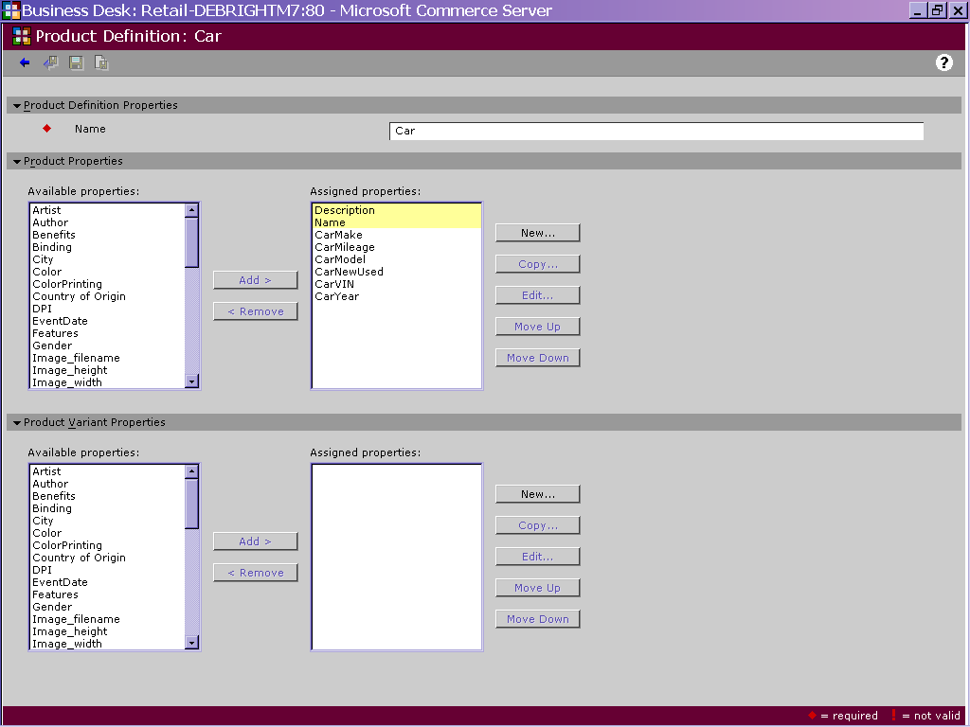
Figure 2 - Product Definition

- Start the Business Desk.
- Click “Catalog”.
- Click “Catalog Designer”. The designer is the tool that allows you to create your catalog schema.
- Click the icon.
- Click “Product Definitions”.
- Click the icon create a new product definition.
- Use the “Car” table above to create the product definition.
- Click the icon to save the product definition and exit the page.

Create A New Category Definition
The final step in defining a catalog schema is to create category definitions. A category definition is different from a category value. For example, you might have a category definition named “Department”. A category value for this might be “Men’s Clothing”, “Women’s Clothing” or “Shoes”.

In this exercise, we want to categorize our various car categories. So we will create a definition named “Car Category”. Follow these steps to create this category definition:

- Start the Business Desk.
- Click “Catalog”.
- Click “Catalog Designer”.
- Click the icon.
- Click “Category Definition”.
- Click the icon to create a new category definition.
- Name the category “Car Category”.
- Click the icon to save the new category definition and exit.

At this point, you have defined the product and category definitions for your new catalog. The next step in building a catalog is to add products to the catalog, and then categorize your products to enable users to search/navigate the catalog on your site.

Before you can add products, you must first create a new catalog instance that will hold the products. To create a new catalog instance, follow these steps:

Create A New Catalog Instance
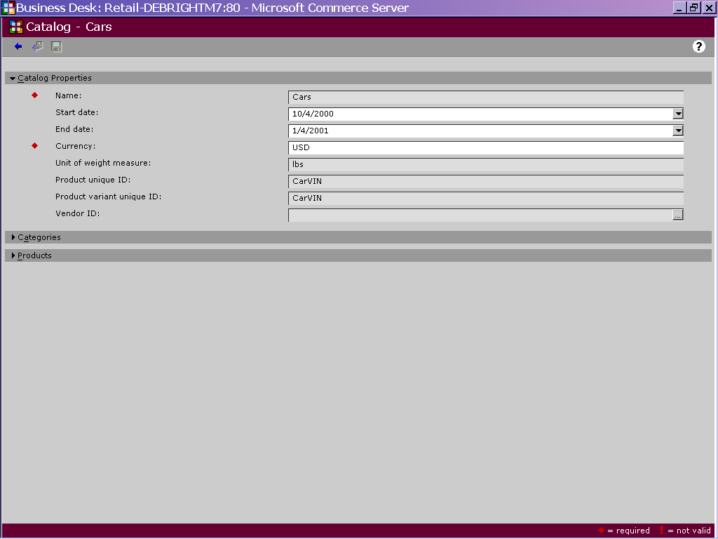

- Start the Business Desk.
- Click “Catalog”.
- Click “Catalog Editor”.
- Click the icon to add a new catalog. It is through this interface that you will create the new catalog instance, add categories values, add products and categorize your products.
- Name the catalog “Cars”.
- Provide valid start dates and end dates.
- Select CarVIN as the product ID and product variant ID (although we are not implementing variants).
- Save the catalog by clicking the icon, but do not exit the catalog page.

Add Category Values to Category Definition
Next, we need to add a list of categories to our “Car” definition. These categories will allow shoppers to browse the catalog by category. The following list of categories values will be created:

Category Values
Year 1997 1998 1999 2000
Make Ford Mercedes Toyota BMW
Model Taurus E320 Camry 740

Please Note: You will create a category value for EACH of the 15 values listed in the previous table, including values named year, make and model.

When you create a category tree in Commerce Server, you first create all the categories, and then you organize them afterwards. Follow these steps to create the category values. You will not organize them into a category tree until the next section:

- On the catalog page, you will notice a section named “Categories”. Expand this section and click the “New” button.
- A list drop will appear asking you to choose the category definition type. Select “Car Category” and click “Continue”.
- Use the table above to create a category for each of the values. You only need to provide the category name at this point. You may click the icon to create multiple category values without exiting this page.
- Click the icon when you have added all of the category values.

Next we need to organize our category hierarchy. The category hierarchy allows you to implement category tree that users can navigate to find products. We will implement the following category hierarchy:

Category Hierarchy
- Year
  - 1997
  - 1998
  - 1999
  - 2000
- Make
  - BMW
  - Ford
  - Mercedes
  - Toyota
- Model
  - 740
  - Taurus
  - E320
  - Camry

Follow these steps to implement this category hierarchy:
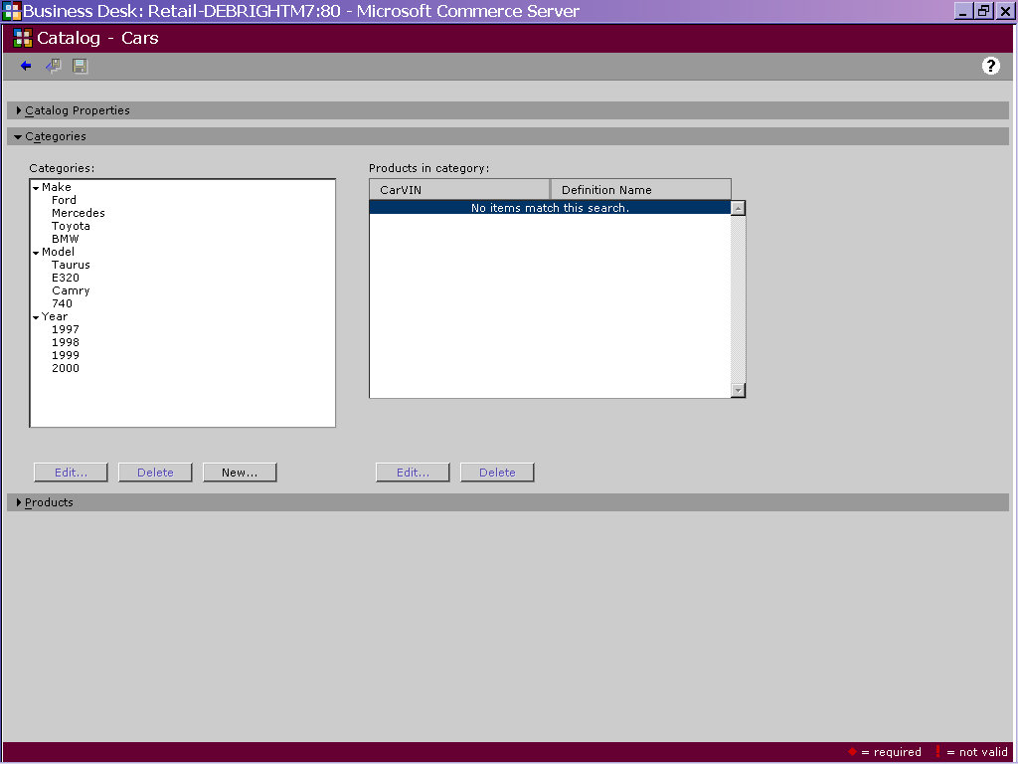

- In the “Categories” section, you should now see a list of all the categories you previously created
- Let’s begin the category tree by placing all of the years under the “”Year” category. To do this, click the “Year” category in the categories listbox.
- Click the “Edit” button.
- You will notice a list box named “Assigned Categories”. This list box allows you to assign child categories to a parent category. In this case, we want to place all of the years under the “Year” category.
- In the “Available Child Categories” list box click all of the years (1997 thru 2000).
- Click the “Add” button to add these as children of “Year”.
- Click the icon to save category hierarchy and exit.
- Repeat steps 2-7 for the “Make” and “Model” categories listed above.

Add Products to Catalog
The final step in implementing the catalog is to add products. We will add the following products to the catalog:

VIN | Name | Description | CarYear | CarMake | CarModel | CarMileage | CarNewUsed | Price
111-111 | Camry | Great car! | 1999 | Toyota | Camry | 20000 | Used | 19995
222-222 | Camry | Needs work. | 1997 | Toyota | Camry | 98000 | Used | 12000
333-333 | E320 | Live a little! | 2000 | Mercedes | E320 | 0 | New | 45000
444-444 | Ford | Reliable car! | 1998 | Ford | Taurus | 20000 | Used | 14000
555-555 | BMW | Luxury!! | 1999 | BMW | 740 | 10000 | Used | 65000
666-666 | BMW | Buy me!! | 2000 | BMW | 740 | 0 | New | 75000

Follow these steps to add these products to the catalog:
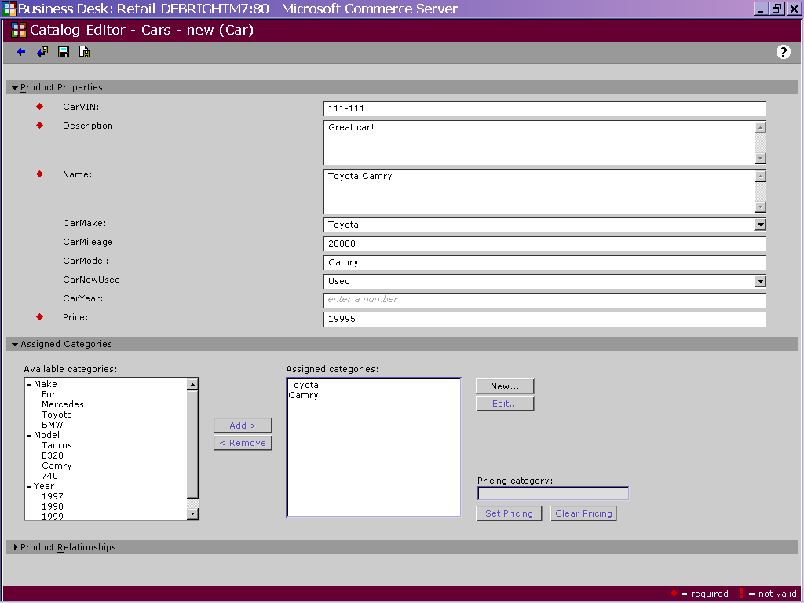

- Click the “New” button in the “Products” section of the catalog properties page.
- Click “Car” then click “OK”.
- Use the table above to fill out the product page.
- In the “Assigned Categories” section, click the appropriate categories to which the product should be assigned. For example, the first product (111-111) would be assigned to 1999, Toyota and Camry.
- Click the “Add” button to match this product to the category.
- Click the icon to save the product and exit.
- Repeat steps 1-9 for each of the remaining product listed above. Use the following table to categorize the products:

At this point, you have implemented a fully functioning CS2000 catalog. You can test your catalog by starting the shopper site you unpackaged for this lab (most likely located at http://localhost/retail ).

You must refresh the catalog management system prior to performing catalog searches. The Catalog Management System relies on the SQL-Server Full Text Search Engine. Refreshing the Catalog Management System will trigger SQL-Server to re-index your newly added catalog data. Follow these steps to refresh the catalog system:

Refresh the Catalog Management System
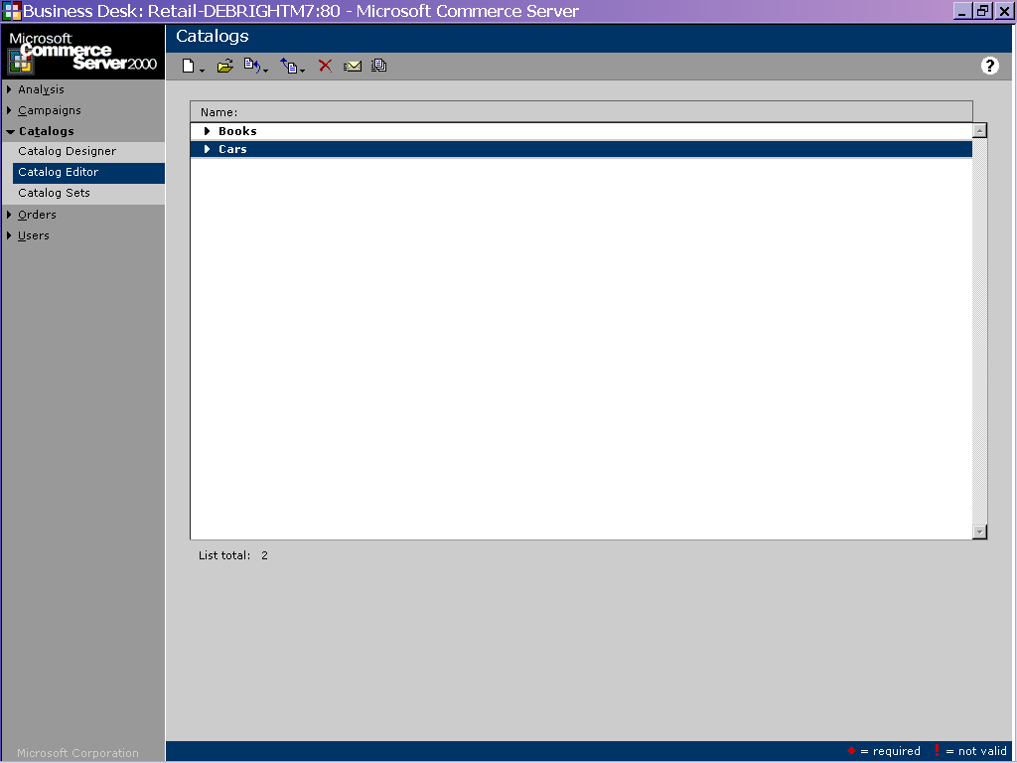

- Start the Business Desk,
- Click “Catalogs”.
- Click “Catalog Editor”.
- Click the icon to refresh the Catalog Management System. This updates both the web server catalog caches, as well as the SQL-Server full text search catalogs.

Take a moment to test your new catalog.

Custom Pricing
In many scenarios, product pricing varies among customers. For example, a large company may negotiate a substantial price discount based on the volume of sales they place with a site. Commerce Server 2000 allows a catalog administrator to implement custom pricing to support this scenario.

Custom pricing works by applying a discount to a base catalog. For example, you might have a catalog named “Cars”. You could create a custom catalog that is based on this catalog named “Boston Auto Wholesaler Catalog”. This catalog would inherit all of its products from the “Cars” catalog. However, you can tell Commerce Server to apply a discount or markup to the product prices for the “Boston Auto Wholesaler” catalog.

In this section, we will create a custom catalog named “Boston Auto Wholesaler Catalog”. This catalog will give a 5% discount on all products in the catalog. Follow these steps to implement this custom catalog:

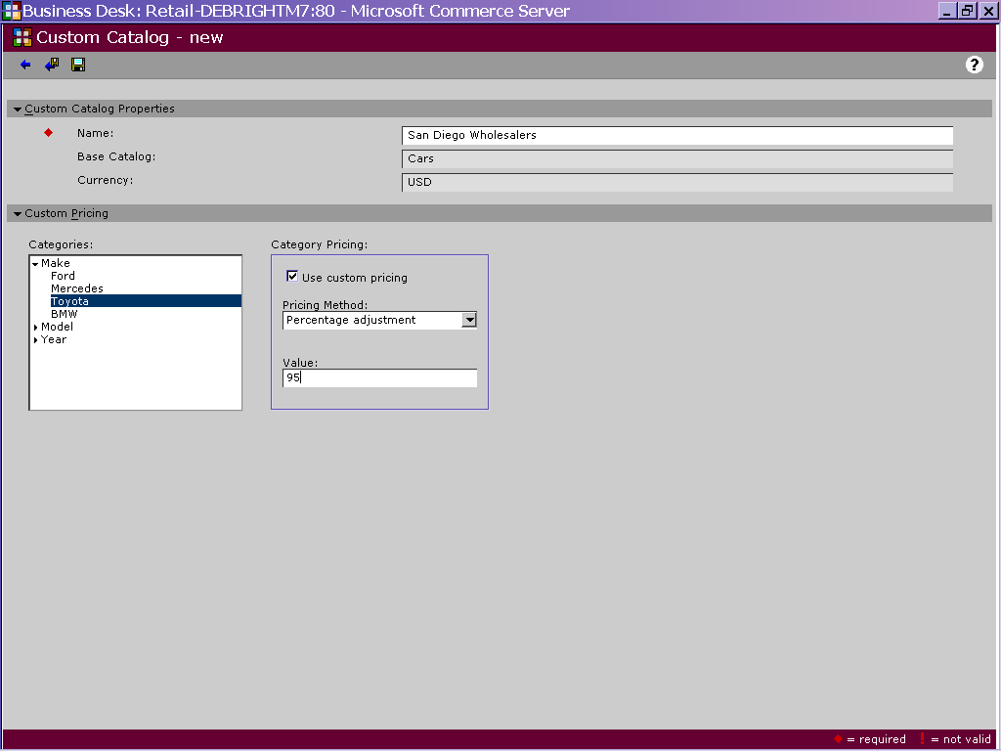

- Start the Business Desk.
- Click “Catalogs”.
- Click “Catalog Editor”.
- Click the icon.
- Select “New Custom Catalog” from the menu.
- Select “Cars” as the base catalog, then click OK.
- Name the custom catalog “Boston Auto Wholesaler Catalog”.
- Click the “Ford” category from the category list then select “Taurus”. Notice that this option gives you the flexibility to limit custom pricing by product category.
- Check the “Custom Pricing” checkbox.
- Select “Percentage Adjustment” as the “Pricing Method”.
- Enter 95 as the value. Note that the percentage adjustment option set the price at a percentage of the base price. So, 95 means 95% of its base price, which represents a 5% discount.
- Click the icon to save the custom catalog and exit.
- Click the icon to update the catalog list. Once refreshed, you should notice you new catalog in the catalog list.

Revisit your shopper site. You will notice the custom catalog appears in the catalog list. Test the custom catalog to verify the custom pricing is being properly applied.

Applied Learning
In the previous sections you learned how to implement a Commerce Serve catalog. Using what you learned, try to implement another catalog product on your own. Here are the specs on the product:

Product Name | Rim
Product Properties | RimSKU, RimSize, Name, Description
Category Def Name | Rim Category
Categories | 15 inch, 16 inch, 17 inch
Products | Chrome E320, Silverado BMW, Golden Boy Mercedes, Super Alloy Taurus

Using the knowledge gained in this lab, add this new product type to your “Cars” catalog that meets these requirements.

Extra Credit Exercise
If you have extra time, try the “Catalog Sets” feature to limit the “Boston Auto Wholesaler Catalog” catalog to registered users. This feature allows a catalog administrator to restrict which catalogs can be used by certain users or user groups.

Alternately, you may also want to play with the “Related products” feature of the catalog. This feature allows you to link together products for the purpose of cross-sell, up-sell or product bundles. If you successfully implemented both the “Car” and “Rim” products, try relating several products together. For example, link the Mercedes E320 car product to the Chrome E320 rim product. You can find the interface to relate products on the page you used to enter your product data. The page looks as follows:

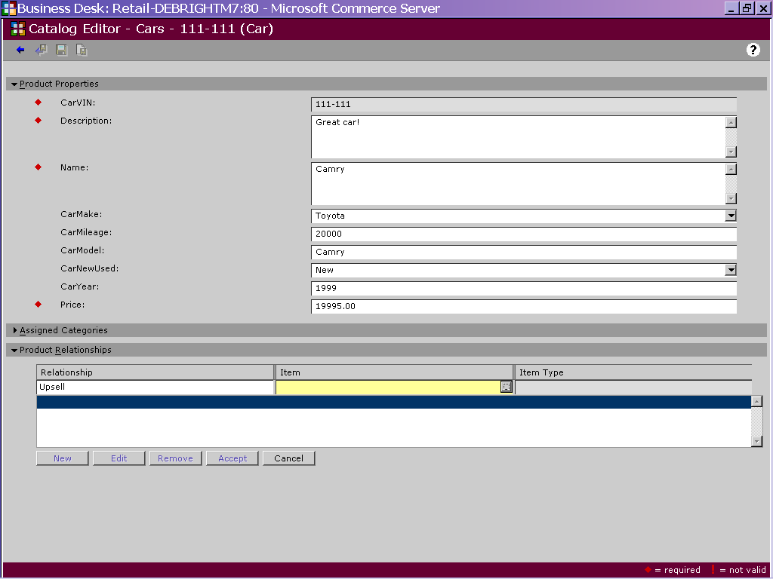

The current solution sites do not automatically display product relationships. However, you can author you own page to see how the related products feature works. Use the Catalog API to author the page. The instructor for this section should have an example displayed that shows how to implement such a page into the site.

