User Management Lab

User Management Lab 1
Objective 2
Setup 2
Lab: How to add custom attributes to the users profiles 2
Create Database Columns for the New Attributes: 3
Use the Commerce Server MMC to Extend the User Profile 3
Create the Data Members 3
Create the Custom Properties 4
Lab: How to Use the Commerce server 2000 Business Desk to create site terms 6
To Add a Site Term to a User Profile 6
To Create a Site Term 7
Lab: How to Use the Business Desk to create a new user 9
Create the organizations: 9
Create new users 10
Limit the Catalogs the user can order from Error! Bookmark not defined.
Dealing with Legacy User Data 12
Migrating Existing User Data 12
Extra Credit: Aggregating Data Sources 14

Objective
The objective of this lab is to learn how to extend and manage the Commerce Server 2000 User Profile System. Specifically, this lab will cover the following topics:

Topics Covered
- How to add custom attributes to a profile
- How to use the Commerce Server 2000 Business Desk to create site terms
- How to use the Commerce server 2000 Business desk to create a new user
- How to use the Commerce server 2000 Business Desk to associate the users to specific organizations
- How to limit the catalogs a user can order from
- How to perform a bulk import of users from an existing database, via the User Profile API

These topics will provide the basic knowledge needed to get started with the Commerce Server 2000 User Profile System. For a more exhaustive overview of User Profile System please reference the Commerce Server 2000 online Documentation.

(The estimated time to complete this lab is 60 minutes.)

Setup
In order to complete this lab, you will need a machine setup with Windows 2000, SQL Server SQL 2000, IE 5.5 and Commerce Server 2000.

Lab: How to add custom attributes to the users profiles
Virtually every Commerce Server 2000 customer will need to customize the out-of-the-box user profile. They will want to customize the user profile to include user properties that are relevant to their web application, specifically as it relates to personalization. For example, a customer might determine that they would like to personalize their site based on a user’s age, gender, country, language, etc.

Adding custom attributes is a 3-step process. The first step is to allot space within SQL Server to actually store the custom attributes. In the first section of the lab, we will use the SQL Server MMC to create database columns for new 3 user attributes (age, price sensitivity and geographical region):

Create Database Columns for the New Attributes:
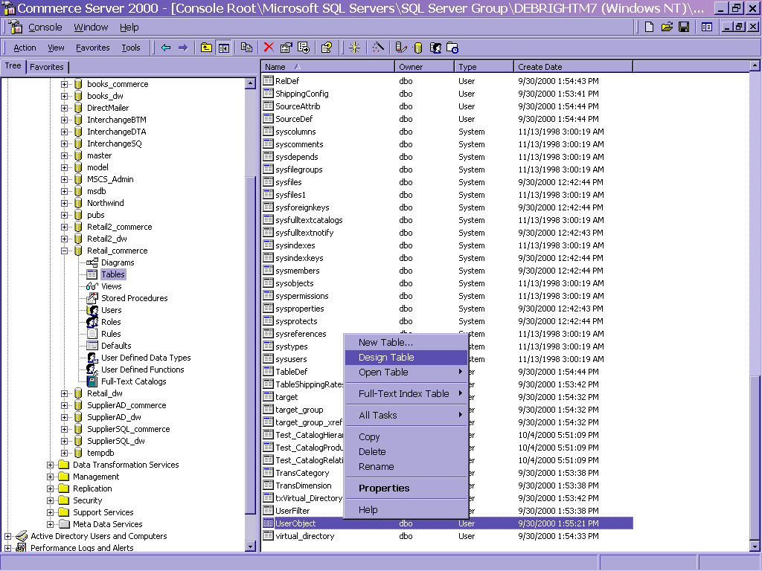
Figure 1 - Adding Database Columns

- Start the Commerce Server Manager.
- Open the Microsoft SQL Server MMC.
- Navigate to the the Retail_commerce database.
- Find the UserObject table within the Retail_commerce database.
- Right mouse click on the UserObject table and go into design mode by selecting Design Table.
- A dialog box named “Design table:UserObject table” appears. Scroll to the bottom of the list and add the following 3 new columns:
  - i_age, integer
  - u_region, char, length of 10
  - u_price_sensitivity, length of 10
- Select the save button to update the UserObject table with your changes.
- Close the SQL Server Enterprise Manager.

At this point, your database is configured to store data for the new user attributes.

Use the Commerce Server MMC to Extend the User Profile
In this portion of the lab, you will link the columns previously created in SQL Server to the Commerce Server User Profile System. This requires you to create a data member and a property for each column you just created in SQL Server:

Create the Data Members
A data member is a piece of metadata that points to the database column in SQL Server that stores a user profile data. For each column in your underlying database schema, you must create an associated data member which points to the database column:

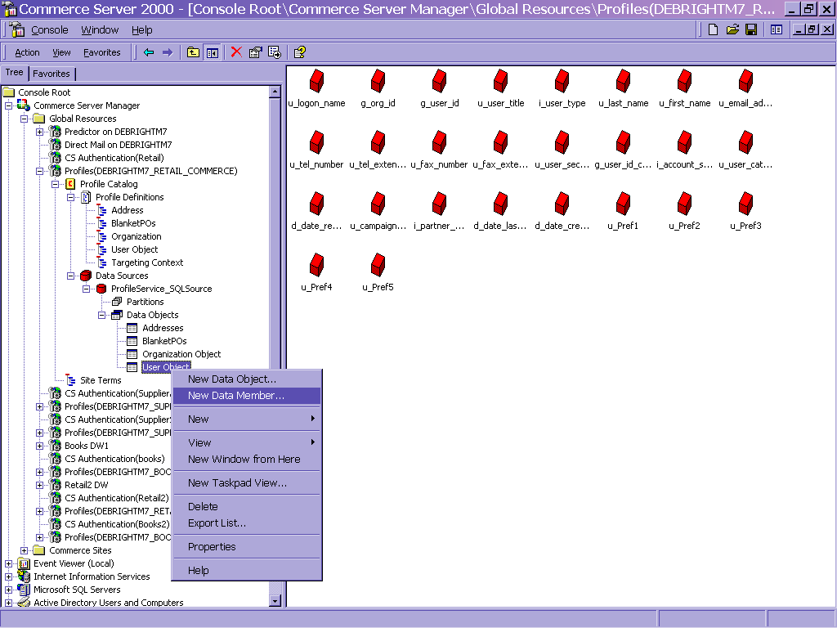
Figure 2 - Adding Data Members

- Start the Commerce Server Manager.
- In the Commerce Server Manager, expand Global Resources, Profiles(Machine name_Retail_commerce), Profile Catalog, Data Sources, ProfileService_SQLSource, Data Objects.
- Right click on the User Object database and select the New Data Member.
- In the dialog that appears, give the data member a name. You can call it whatever you would like, but it might be a good idea to name it the same name as the underlying database column. In this way, it is easy to match the data member to the database column. So, you may wish to name it i_age.
- Scroll down the list and find the database columns named i_age and select it. This will link the data member name to the database column name.
- Give it a display name of Age.
- The data type should have been set to int for you automatically, but if not make this selection in the data type drop down menu.
- Select Add.
- Repeat steps 3-9 to create the u_region data member with a display name of Region of type string.
- Repeat steps 3-9 to create the u_price_sensitivity data member with a display name of Price_Sensitivity of type string.
- Select the Finished button once done.

Create the Custom Properties
The last step in extending a profile is to create a new profile attribute for each new data member. Here are the steps needed to perform this:
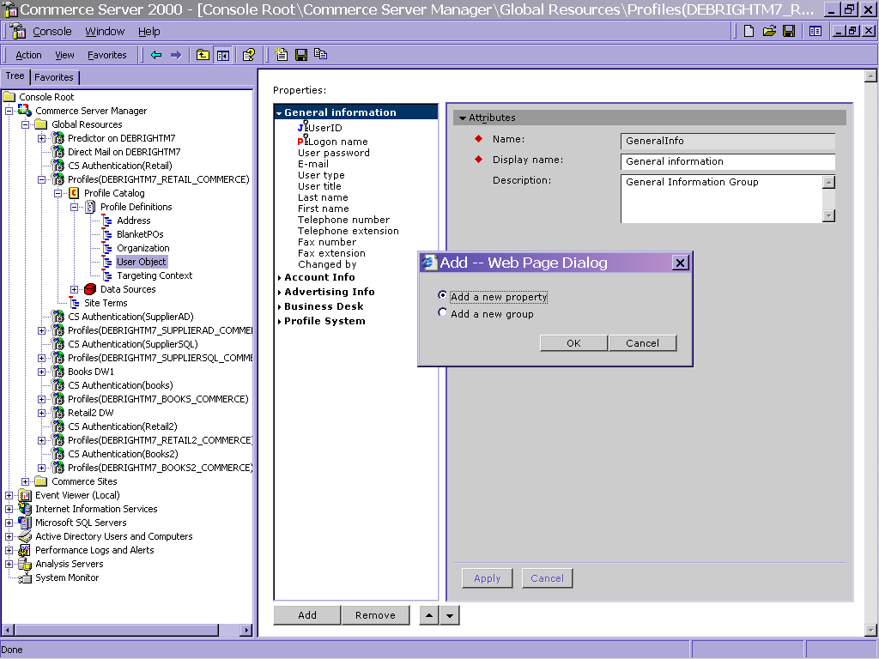
Figure 3 - Adding Profile Attributes
- In the Commerce Server Manager, expand Global Resources, Profiles(Machine name_Retail_commerce), Profile Catalog, Profile-Definitions, and then select the User Object profile definition, which contains all attributes on the user profile.
- You will notice several property groups which give you a way to organize related profile attributes. In this case, we will add our new attributes to the group named General Info. In the Properties list, expand the General Info property group, which is where you want to add this custom attribute to.
- At the bottom of the Properties windows, click Add.
- Be sure Add a new property is selected, and click OK.
- You should now have a dialog on the right side of the window that allows you to configure the new attribute. In the Attributes section, do the following:
Use this | To do this
Name | age
Display Name | Age
Description | This is an optional field. Enter a description if you like.
Type | Number
- The Advanced Attributes section allows you to map the new attribute to its underlying database column. To make this association:
Use this | To do this
Active | Verify Yes is selected.
Map to Data | Click the ellipsis and navigate to the following data member:  ProfileService_SQLSource → User Object → I_age
- At the bottom of the attribute window, you must click the Apply button for your new attribute to be added to the profile definition cache.
- Click the save button in the toolbar to write the profile cache to the database.
- Now repeat steps 3-8 to create the Region attribute. Name it region and enter a description if you wish.
- Now repeat steps 3-8 to create the Price_Sensitivity attribute. Name it price_sensitivity and enter a description if you wish.
Now, let’s take a look at how to create site terms.

Lab: How to Use the Commerce server 2000 Business Desk to create site terms
Site terms are lists of the specific values that are pertinent to your site. You use a site term to assign this list of values as valid choices for a profile attribute. Therefore, site terms provide an easy way for you to standardize the values that are used throughout your site and to target products and advertisements to site users.
For example, in this lab, you will create a site term named Region, and define the following possible values: East, West, South or North. You will then link the Region property to this site term.

To Add a Site Term to a User Profile
In this lab, you will add a site term named Region and give it choices of East, West, South and North. Once you have created your site terms, you will set up a user profile to include the site terms so you can later target an advertisement to those site users that match the user profile.

To Create a Site Term
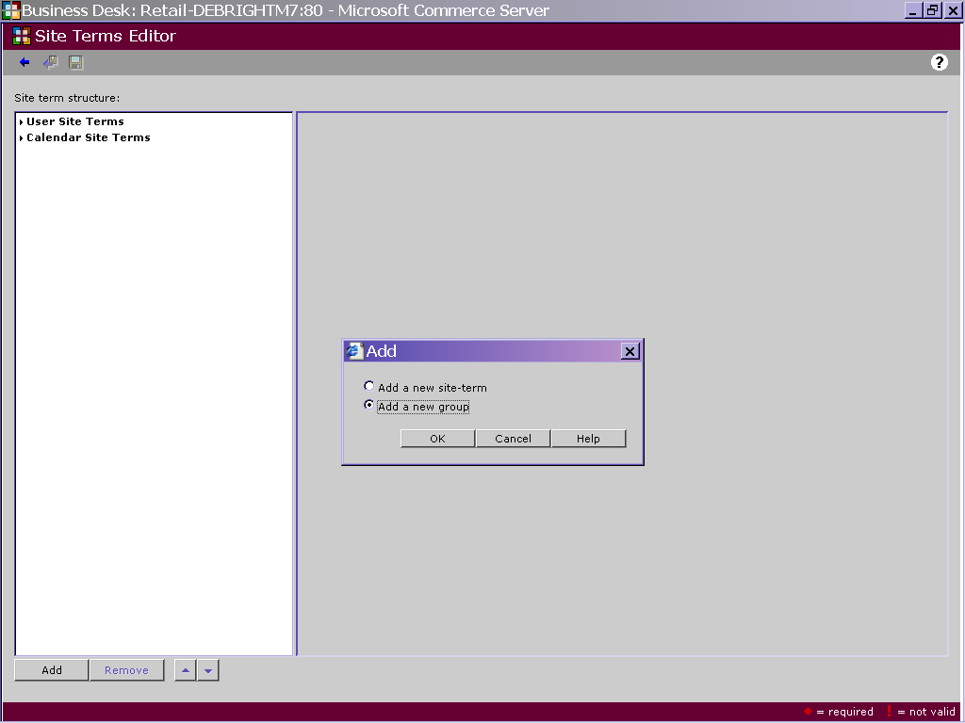
Figure 4 - Create a Site Term
- In the Users module of the Business Desk, select the Site Terms Editor.
- In the Site Terms screen, select Add at the bottom of the screen.
- Let’s create a new group for our site terms by selecting Add a new group, and then click OK.
- In the Site Term Attributes section, name the new group as follows:
Name | Type Personalization
Display name | Type Personalization
- Click Apply to save your new changes.
- Now, let’s add site terms to this new group. In the site term structure list, select Personalization, and then click Add
- Select Add a new site term, and then click OK.
- In the Site Term Attributes section:
Name | Type Region
Display name | Type Region
- Click Accept.
- In the Terms section, create the actual site term names:
Term Name | Type 0
Display name | Type East
- To submit your new changes, click Accept.
- Repeat steps 10-11 to create the West, North and South site term value:
Term Name | Display Name
1 | West
2 | North
3 | South
- Click Apply.
- Click the save icon to commit your changes.
Now that the site term is created, let’s link it to the “Region attribute” to the “Region site term”.
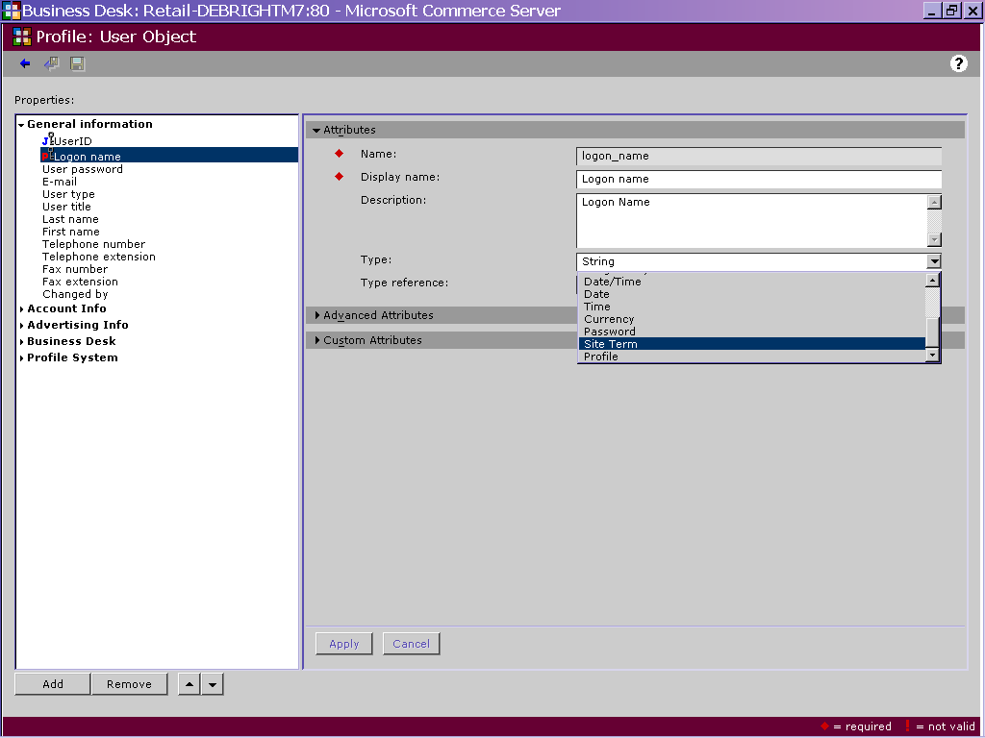
- In Users module of the Business Desk, select Profile Designer.
- In the Profiles screen, in the Name box, select User Object.
- In the Profiles screen, click User Object then click the Open icon.
- In the User Object screen, in the Properties list, expand General Information, and then select Region. This attribute was created in a previous step in this lab.
- In the Attributes section, in the Type drop-down box, select Site Term.
- Next, click the ellipsis next to the Type Reference box.
- Navigate to the Personalization→Region site term and click OK.
- Click Accept, and then Apply.
- To save your work, click the save icon and exit the page.
- To make sure your changes are reflected in Commerce Server, run IISReset from the Taskbar. (Click Start, click Run, type IISReset on the address line, and then click OK. )
At this point, we have extended the user profile, and linked one of the new properties to a site term. Now, let’s actually register new users into our extended user profile system.

Lab: How to Use the Business Desk to create a new user
Commerce Server allows you to specify the name of the company for which a user works. Before you can make this assignment, you must use the Organization module in the Business Desk to create a company profile for each unique organization. To do this:

Create the organizations:
To create these organizations, do the following:
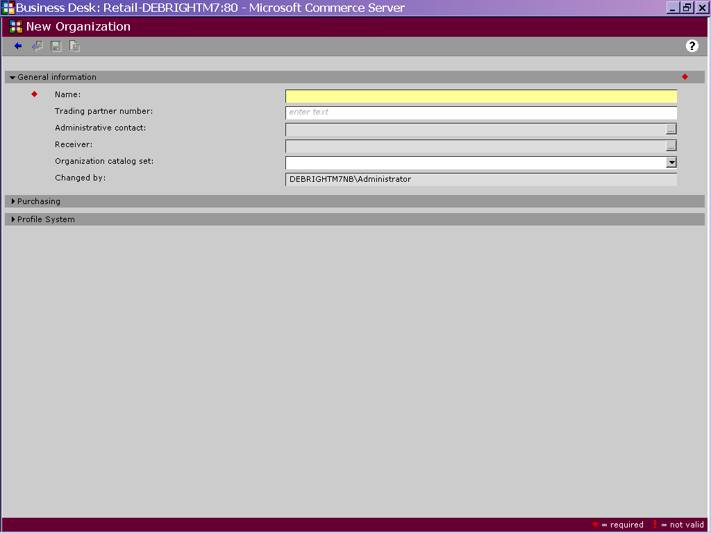
- Start the Commerce Server 2000 Business Desk
- Select the Users module
- Within the Users module, select the Organizations subheading.
- Click the button on the toolbar to create a new organization.
- The new Organization screen appears. Enter Baltimore Automotive Inc. as the organization name and assign users Registered User Default Catalog Set as the default catalog set. Click the icon to save the current organization profile and create another one.
- Create another organization called Boston Auto Wholesalers Inc. Assign Registered User Default Catalog Set as the default catalog set. Click the icon to save the current organization profile and create another one.
- Create one more organization called San Diego BMW and assign users the Registered User Default Catalog Set as the default catalog set.
- Click the icon to save this organization profile, and exit the page.

Create new users
Now lets create users that belong to these organizations:
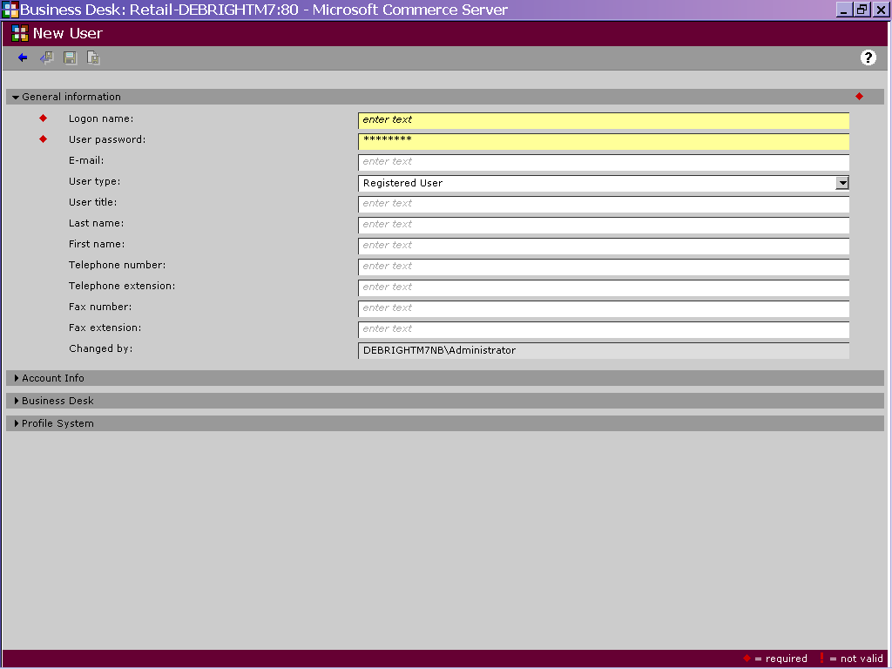

- Within the Users module, select the Users subheading to bring you to the Registered User Management screen
- Click the icon to create a new user. Here is where we will start to enter user information.
- We will create 3 new users (EastUser, SeniorUser and LuxuryUser). Here is the information for each user:

“East User”
Use this | To do this
Logon Name (required) | EastUser
User Password (required) | password
Email | eastuser@msn.com
User Type | Registered
User Title | Mr
Last Name | East
First Name | User
Telephone Number | 703-555-8787
Price Sensitivity | Low
Region | East
Age | 21
“Senior User”
Use this | To do this
Logon Name (required) | SeniorUser
User Password (required) | password
Email | SeniorUser@hotmail.com
User Type | Registered
User Title | Mr
Last Name | Senior
First Name | User
Telephone Number | 703-555-8787
Price Sensitivity | Medium
Region | West
Age | 62
“Luxury User”
Use this | To do this
Logon Name (required) | LuxuryUser
User Password (required) | password
Email | LuxuryUser@msn.com
User Type | Registered
User Title | Mr
Last Name | Luzury
First Name | User
Telephone Number | 703-555-8787
Price Sensitivity | High
Region | West
Age | 42
- In the Business Desk section, select Normal User as the user type. The other option is “Administrator”, which would give the user certain rights within the Business Desk.
- Select from the menu bar to save this new user and return to the Registered User Management screen.
At this point, you have customized the user profile system to include several custom profile attributes. These attributes can be used to perform authentication, access control and personalization within a site. You have also registered several users via the Business Desk. We will use these users in subsequent labs.

Dealing with Legacy User Data

Migrating Existing User Data
Often you will need to migrate user data from an existing user database into Commerce Server 2000. One way of doing this is by writing e a script that reads the data from the legacy data store and inserts it into the Commerce Server Profile System. The code below shows an example of how to use the Commerce Server 2000 API to perform this task.
Modify the code and experiment with programmatically importing user data into Commerce Server. The code uses a DSN to point to the legacy data source. You can simulate this legacy data source by creating a user table in Microsoft Access. The following code uses the Windows Scripting Host to import the user data:
Const SITE_NAME = "Retail"
Const LEGACY_DSN = "dsn=LegacyUserProfile"
Const SCHEMA_CATALOG = "Profile Definitions"
Const PROFILE_TYPE_USER = "UserObject"

call Main()

'******************************************************************
' name: Main
' in: Nothing.
' out: Nothing.
'******************************************************************
Sub Main()

Dim oldShopper
Dim oldShopperInfo
Dim strQuery
Dim mscsProfileSvc
Dim mscsProfile
Dim MSCSAppConfig
Dim mscsAppCfg

set MSCSAppConfig = CreateObject("Commerce.AppConfig")
call MSCSAppConfig.Initialize(SITE_NAME)
set mscsAppCfg = MSCSAppConfig.GetOptionsDictionary("")
set mscsProfileSvc = CreateObject ("Commerce.ProfileService")
Call mscsProfileSvc.Initialize(mscsAppCfg.s_ProfileServiceConnectionString,

SCHEMA_CATALOG)

set oldShopper = CreateObject ("ADODB.Connection")
call oldShopper.Open (LEGACY_DSN)
strQuery = "select shopper_id, name, password, phone, email from LegacyUserData"
set oldShopperInfo = oldShopper.Execute (strQuery)

Do Until oldShopperInfo.EOF
Dim shopper_id
Dim shopper_name
Dim shopper_phone
Dim shopper_pwd
Dim shopper_email

‘Grab the data from the legacy user profile data source
shopper_id = trim(oldShopperInfo("shopper_id"))
shopper_name = trim(oldShopperInfo("name"))
shopper_phone = trim(oldShopperInfo ("phone"))
shopper_pwd = trim(oldShopperInfo ("password"))
shopper_email = trim(oldShopperInfo ("email"))

‘Create a new CS2000 profile for the legacy user
Set mscsProfile = mscsProfileSvc.CreateProfile (shopper_id,

PROFILE_TYPE_USER)
if Err.number <> 0 then
wscript.echo "Error in create profile user"
end if

‘Copy the legacy data to the new CS2000 user profile
mscsProfile.Fields ("GeneralInfo.first_name").Value = shopper_name
mscsProfile.Fields ("GeneralInfo.email_address").Value = shopper_email
mscsProfile.Fields ("GeneralInfo.user_security_password").Value =

shopper_pwd

‘Activate the user’s profile
mscsProfile.Fields ("AccountInfo.account_status”) = 1

‘Save the new CS2000 profile
mscsProfile.Update ()

oldShopperInfo.MoveNext ()
loop
end sub

To test this, use SQL Server to create a simple database table. The table should be named LegacyUserData, and should have the following schema:

Name | Type | Size
Shopper_id (primary key) | Text | 20
name | Text | 20
phone | Text | 20
email | Text | 40
password | Text | 20

This database will simulate the legacy data source. In practice, this database could be any database including Oracle, DB2, SQL Server, Progress, Informix, etc.

Extra Credit: Aggregating Data Sources
In some situations, your customers may not want to migrate existing user data into Commerce Server. Instead, they may require that you integrate with their existing user management system. Commerce Server supports this requirement by allowing you to specify the location and source of the existing user data. The data existing data source can be any OBDC, OLEDB or LDAP compliant data source.

The instructor will lead the class through data source aggregation. For the documented procedure, please see the Commerce Server documentation.

